MSDS 6372 Project 1

Infant Mortality Case Study

**Team members:**

Kottegoda Manjula

Messa Araya

Kumar Rajeev

Date:2016-09-20

**Introduction**

Our team decided to analyze the world infant mortality rate, a widely used indicator of the level of health in a country, to see what factors influence this statistic. Infant mortality rate is the probability of a child born in a specific year or period dying before reaching the age of one, if subject to age-specific mortality rates of that period and is expressed as rate per 1000 live births. The data for the study was gathered from the CIA world fact book website. Our goal for the project was to find which characteristics of a nation contribute to the infant mortality rate of that nation. We analyzed eleven explanatory variables in this study.

The explanatory variables looked at in the study are Population, Median Age of the country, Population growth rate, Birth rate, Maternal death rate, Health expenditure by government, Gross Domestic Product - per capita, Tax Revenue, Unemployment rate, Rate of Obesity and the Total fertility rate of the country. We wanted to see which factors were correlated and which factors had a direct effect on a country’s infant mortality rate.

**Descriptive Statistics**

As explained in the introduction, we decided to work with the response variable of infant mortality rate. To begin our study, we need to determine what factors have an effect on infant mortality rate. We went through a process of the data gathering and making sure we have the complete data for the most influential variables we wanted to analyze. All the explanatory variables were continuous variables. Finally, we ended up with a dataset of 155 observations from the initial 238 observations.

We first look at the initial scatter plots of the original (non-transformed) data to determine the rough relationship between variables. As it can be observed from the scatter plot matrix (Fig 1) some of the explanatory variables have linear relationship.



Fig. 1 Scatter plot Matrix

Also we compared the scatter plots of each explanatory variable with response variable individually (Fig. 2) to look at how they are related with the response. Some of the explanatory variables such as birthrate have a strong linear association with the response.

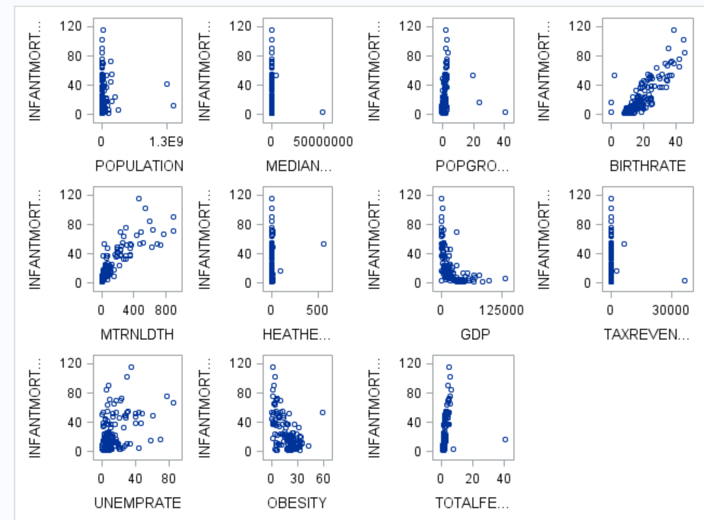

Fig. 2 Scatter plots for explanatory vs. response variables

The individual distributions are not necessarily important if the overall effect (residual plots) are satisfied with the linear regression assumptions. For that reason, we inspected the residual plots Cook’s D (Fig. 3) and Studentized residual (Fig. 4). The Cook’s D shows all the plots are less than 0.25 which is not a problem. The outliers have less influence on the regression.

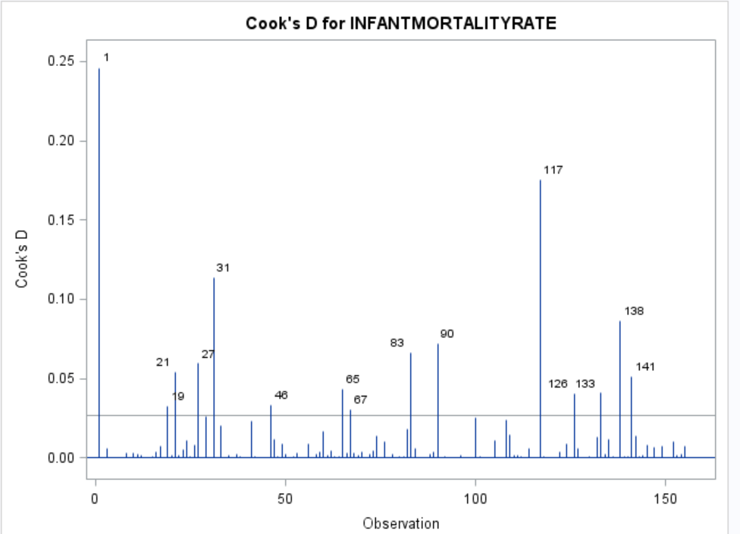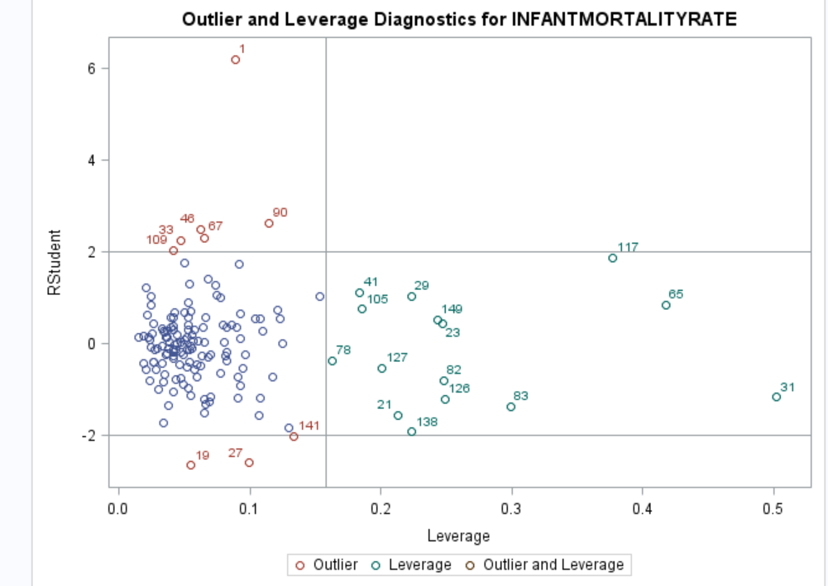

Fig. 4 Studentized residual distribution

Fig. 3 Cook’s D

After examining the regression residual plots (Fig. 5) the residuals don’t seem to be randomly distributed. Also, the variability is not constant. This tells us that the data needs some transformations.

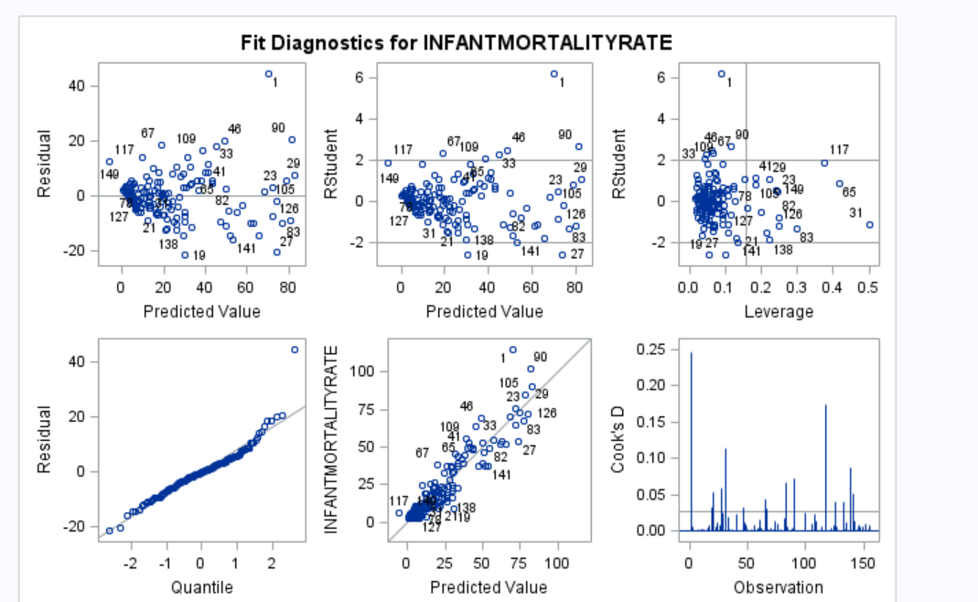

Fig. 5 Fit Diagnostic plots

There are significant differences in the distribution of the residuals for each regressor in Fig 6.

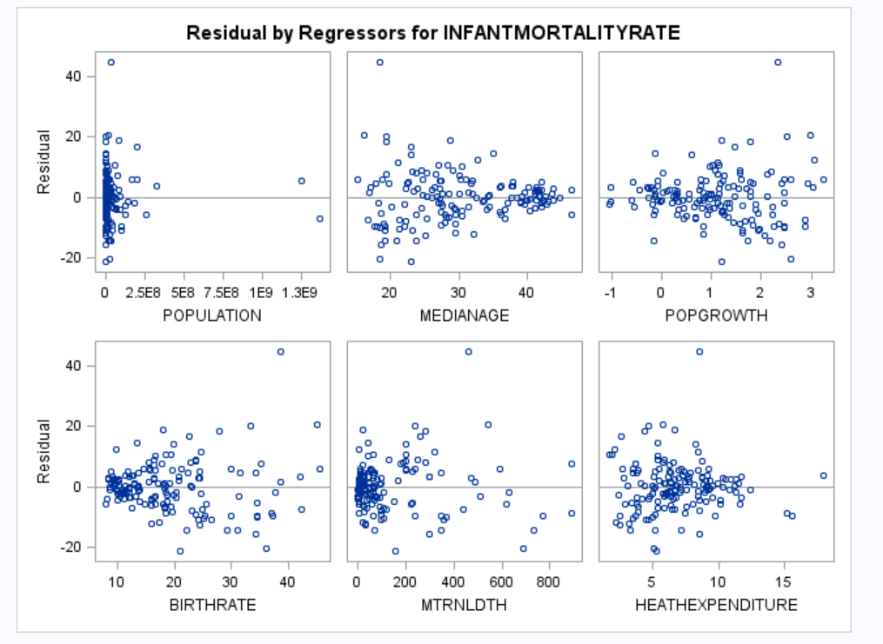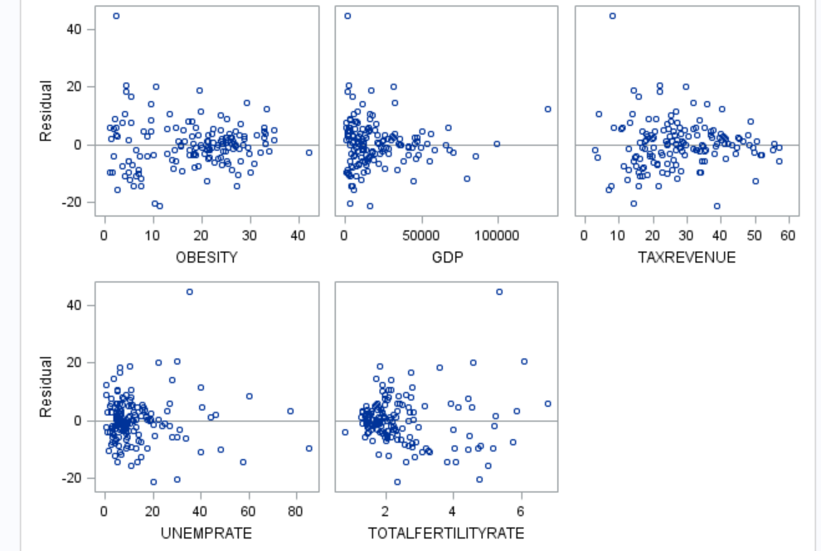

Fig. 6 Residual distribution for individual repressor variables

Before transformation, however, those variables that are highly correlated are filtered using correlation matrix (Table 1) and the variance inflation factor, VIF (Table 2). Based on that criteria we removed four variables (birthrate, population growth, maternity death, and total fertility rate).

|  |  |  |  |  |  |  |  |  |  |  |  |  |
| --- | --- | --- | --- | --- | --- | --- | --- | --- | --- | --- | --- | --- |
| **Table 1 Correlation Table (Partial Snapshot)** | | | | | | | | | | | | |
| **Variable** | **POPULATION** | **MEDIANAGE** | **POPGROWTH** | **BIRTHRATE** | **MTRNLDTH** | **HEATHEXPENDITURE** | **OBESITY** | **GDP** | **TAXREVENUE** | **UNEMPRATE** | **TOTALFERTILITYRATE** | **INFANTMORTALITYRATE** |
| **POPULATION** | 1.00 | 0.03 | -0.02 | -0.04 | 0.00 | -0.06 | -0.20 | -0.06 | -0.18 | -0.10 | -0.04 | 0.03 |

|  |  |  |  |  |  |  |
| --- | --- | --- | --- | --- | --- | --- |
| **Table 2 Parameter Estimates** | | | | | | |
| **Variable** | **DF** | **Parameter Estimate** | **Standard Error** | **t Value** | **Pr > |t|** | **Variance Inflation** |
| **Intercept** | **1** | -9.90132 | 14.65476 | -0.68 | 0.5004 | 0 |
| **POPULATION** | **1** | 2.221289E-9 | 4.759207E-9 | 0.47 | 0.6414 | 1.13294 |
| **MEDIANAGE** | **1** | 0.27147 | 0.33530 | 0.81 | 0.4195 | 16.54200 |
| **POPGROWTH** | **1** | -1.08842 | 1.72270 | -0.63 | 0.5285 | 5.62747 |
| **BIRTHRATE** | **1** | 2.08309 | 0.75644 | 2.75 | 0.0067 | 92.80646 |
| **MTRNLDTH** | **1** | 0.04092 | 0.00666 | 6.14 | <.0001 | 3.23993 |
| **HEATHEXPENDITURE** | **1** | -0.29763 | 0.30795 | -0.97 | 0.3355 | 1.51907 |
| **OBESITY** | **1** | -0.35050 | 0.09795 | -3.58 | 0.0005 | 1.89215 |
| **GDP** | **1** | -0.00000467 | 0.00005956 | -0.08 | 0.9376 | 3.32547 |
| **TAXREVENUE** | **1** | -0.05494 | 0.07406 | -0.74 | 0.4594 | 1.67995 |
| **UNEMPRATE** | **1** | 0.09894 | 0.05788 | 1.71 | 0.0896 | 1.30952 |
| **TOTALFERTILITYRATE** | **1** | -3.95380 | 4.07130 | -0.97 | 0.3332 | 45.74967 |
|  |  |  |  |  |  |  |

Looking at the residual and scatter plots the most appropriate options will be the Log () transformation. This transformation will uniform the variability and normalize the distribution. Log transformation was done for the response variable and GDP per capita.

The variance inflation factor of the variables is greatly improved after transformation as shown in Table 3 below. This shows that the collinearity between explanatory variables is eliminated.

***Table 3 Parameter Estimates***

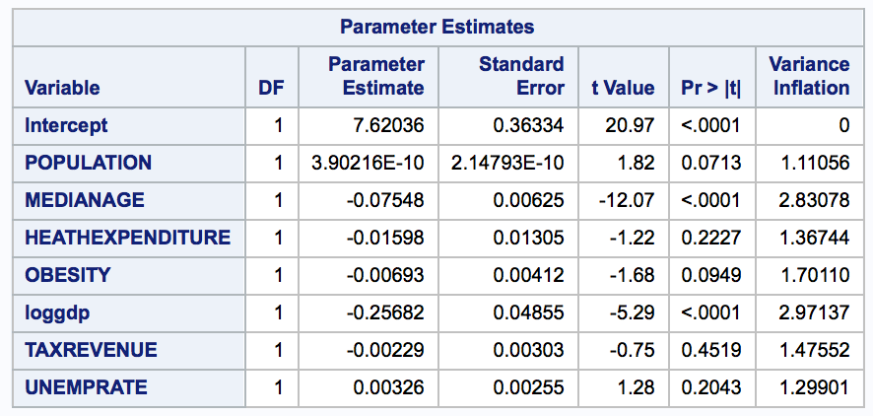

**Analysis**

Linear regression is appropriate. Because the following major simple linear regression assumptions are satisfied.

* **Linearity between variables**-The linearity assumption can be assessed from the predicted vs. residual/Studentized residual scatter plots (Fig. 7). Although there is widespread scatter in the residual plot, there is no apparent pattern or relationship between the residuals and predicted values. The residuals appear to be almost evenly spread above and below 0 for the differing values of predicted values. We can conclude that the linear model is appropriate for the given data.
* **Independence between observations**- The observations are independent of each other.
* **Normality of populations or errors**- We can see this from quantile vs residuals (QQ) plot that the data do not appear to depart substantially from a normal distribution. The robustness of regression analysis with modest departures from normality enables us to conclude that we should not be overly concerned about departures from this normality assumption in the given data. Also the histogram shows almost symmetric or normal density plot. This is shown in Fig.9 below.

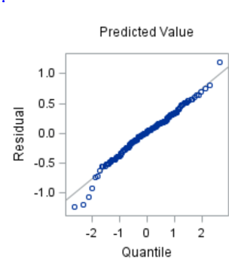 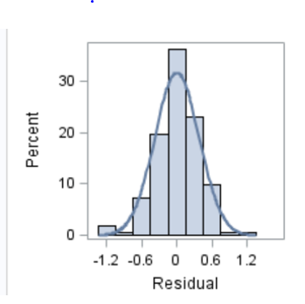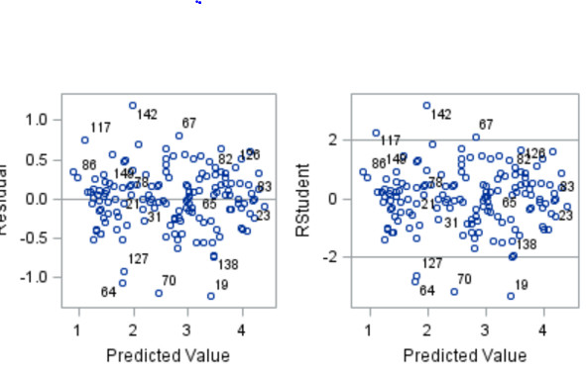

Fig. 7 Residual distribution

* **Equal Variance-**we can evaluate the assumption of equal variance from a plot of the residuals with predicted values again. The scatter plots do not appear to be major differences in the variability of the residuals for different predicted values (Fig 7). Thus, we can conclude that there is no apparent violation in the assumption of equal variance at each level of predicted values.
* **Observations must be quantifiable**: This is true as each observation is quantifiable by decimal

***Build a Model:***

After considering the availability of the data and to simplify the model we reduced the number variables to 11. Multiple collinearity tests were conducted to determine if the remaining 11 variables were measuring similar aspects of the model. Variables such as **TOTALFERTILITYRATE, POPGROWTH, BIRTHRATE** were taken out of the model due to their high collinearity with **MEDIANAGE**. The remaining variables have a variation inflation factor (VIF) of 2.9 or less.

We conducted a variable selection procedure using the LARS algorithm with the cross validation splitting the data randomly into five groups (4 used to test the variables and 1 to validate) and the stop criteria is AIC. The process selected variables which affect the log of infant mortality rate of countries (**logINFANTMORATLITYRATE**).

The result of the variable selection process is:

**Table 4 GLMSELECT Procedure Table**



***Fit the model:***

To make sure the variables above fit the model we ran regression multiple times so that all the variables from the model are significant.

**Table 5 ANOVA Table**



**Table 6 Parameter Estimate Table**



The above table shows the parameter estimates of statistically significant variables, their p-values and the VIF.

***Table 7 Check the Model Fit (lack of fit test):***



The linear model is a good fit (p-value < 0.0001) with an Adjusted R2 = 0.8547.

The final model equation is as follows:

$$logINFANTMORATLITYRATE=7.64-(0.079)MEDIANAGE-(0.009)OBESITY-(0.253)logGDPPerCapita$$

or

$$INFANTMORATLITYRATE=e^{7.64}∙{\left(e^{-0.079}\right)}^{MEDIANAGE}∙{\left(e^{-0.009}\right)}^{OBESITY}.{\left(e^{-0.253}\right)}^{logGDPPerCapita}$$

|  |  |
| --- | --- |
| Unit Increment of variable | Multiplicative Change of the median of Infant Mortality Rate |
| MEDIANAGE | 0.924 |
| OBESITY | 0.99 |
| GDP per capita (Doubling of this) | 0.7764 |

**Interpretation & Conclusion**

With the data that was analyzed in the study we see a clear relationship between the infant mortality rate and the median age of a nation’s population, obesity rate of that particular nation as well as the GDP - per capita. The fitted model with an adjusted R2 greater than 0.85 show that all these factors have a strong influence on the infant mortality rate. Furthermore, the fitted model also show the factors mentioned above having a negative correlation to the infant mortality rate. A lower infant mortality rate is the desired goal of all nations and as such these variables can be used as a reliable measurement of a given country’s health.

The interpretation of the resulting model yields some interesting findings as well as general expected ones. For example, the high level of Collinearity seen amongst the fertility rate, population growth, birthrate and the median age are somewhat expected. As in younger populations being more fertile and having more children resulting in higher birthrates which in turn translates to higher population growth rates.

While the model’s selected variables are somewhat expected, some of the variables that were left out are equally intriguing. The most striking observation being that a high healthcare expenditure did not necessarily translate to a statistically significant lower infant mortality rate. While one can argue that this is counter intuitive further study needs to be done on the subject to see where the actual spend ends up. For example, countries with aging, obese and other disease prone populations will get burdened by high costs of treating diseases rather than investing in preventative care there by skewing the measurement against common sense expectations.

Another unexpected observation is the obesity rate’s relationship with the infant mortality rate. Holding the Median age and GDP - per capita at a constant level, for every percentage increase in obesity rate the country’s infant mortality rate seem to decrease by 0.9%. Further examination shows that obesity rates are higher in developed nations where higher quality healthcare is available there by lowering infant mortality rates.

At first glance the Median age seems to have the biggest influence on the infant mortality rate. But when looking at the range of values for each variable GDP - per capita has the biggest impact in lowering the infant mortality rate of a given nation.

**Appendix**

/*Step-1 Importing the data set*/

**data** Project1;

infile "\\Client\C$\Users\ARAYA ABADI\Desktop\EXPERMENTALSTAT2_6372\PROJECT1DataSet.csv" dlm="," firstobs=**2**;

input COUNTRY $ POPULATION MEDIANAGE POPGROWTH BIRTHRATE MTRNLDTH HEATHEXPENDITURE GDP TAXREVENUE

UNEMPRATE INFANTMORTALITYRATE OBESITY TOTALFERTILITYRATE;

**run**;

**proc** **print** noobs data=Project1;

**run**;

/*Step-2 a closer look on the variable scatterplots*/

**proc** **sgscatter** data = Project1;

matrix POPULATION MEDIANAGE POPGROWTH BIRTHRATE MTRNLDTH HEATHEXPENDITURE GDP TAXREVENUE

UNEMPRATE INFANTMORTALITYRATE OBESITY TOTALFERTILITYRATE/diagonal=(histogram kernel)

ellipse=(type=mean);

**run**;

/*Step-3 scatterplot as compared the explanatory variables with the response(y)*/

**proc** **sgscatter** data=Project1;

plot INFANTMORTALITYRATE*POPULATION INFANTMORTALITYRATE*MEDIANAGE INFANTMORTALITYRATE*POPGROWTH

INFANTMORTALITYRATE*BIRTHRATE INFANTMORTALITYRATE*MTRNLDTH INFANTMORTALITYRATE*HEATHEXPENDITURE

INFANTMORTALITYRATE*GDP INFANTMORTALITYRATE*TAXREVENUE INFANTMORTALITYRATE*UNEMPRATE INFANTMORTALITYRATE*OBESITY

INFANTMORTALITYRATE*TOTALFERTILITYRATE;

**run**;

/*Step-4 Looking the variables using univariate*/

**proc** **univariate** data=Project1;

histogram;

**run**;

/*Step-5 Looking the regression before transformation*/

**Proc** **Reg** Data=Project1 corr plots(label)=(rstudentleverage cooksd);

*plots(unpack label);

model INFANTMORTALITYRATE = POPULATION MEDIANAGE POPGROWTH BIRTHRATE MTRNLDTH HEATHEXPENDITURE OBESITY GDP TAXREVENUE UNEMPRATE TOTALFERTILITYRATE / partial VIF ;

**run**;

/*Step-6 Transformation of the response and PERCAPITA=GDP/POPULATION*/

**data** Project2;

set Project1;

logINFANTMORTALITYRATE=log(INFANTMORTALITYRATE);

loggdp=log(GDP);

**run**;

**proc** **print** data=Project2;

**run**;

/*Step-7. Model Building - To Exclude Highlighly Correlated Variables from the Model*/

**Proc** **Reg** Data=Project2 corr plots(label)=(rstudentleverage cooksd);

*plots(unpack label);

model logINFANTMORTALITYRATE = POPULATION MEDIANAGE POPGROWTH BIRTHRATE MTRNLDTH HEATHEXPENDITURE

OBESITY loggdp TAXREVENUE UNEMPRATE TOTALFERTILITYRATE / partial VIF ;

**run**;

/*Step -8 Model Building - Excluding Highlighly Correlated Variables from the Model*/

**Proc** **Reg** Data=Project2 corr plots(label)=(rstudentleverage cooksd);

*plots(unpack label);

model logINFANTMORTALITYRATE = POPULATION MEDIANAGE HEATHEXPENDITURE OBESITY loggdp

TAXREVENUE UNEMPRATE /*BIRTHRATE POPGROWTH MTRNLDTH TOTALFERTILITYRATE*/ / partial VIF ;

**run**;

/*Step -9 Model Building - Variable Selection Process Using LARS Algorithm*/

**Proc** **GLMSELECT** data=Project2;

model logINFANTMORTALITYRATE = POPULATION MEDIANAGE HEATHEXPENDITURE OBESITY loggdp TAXREVENUE

UNEMPRATE / selection=LARS(choose = cv stop = aic) cvmethod = random(**5**) stats = (adjrsq cp bic sbc sl);

**run**;

/*Step -10 Model Building - Fit Linear Regression Model*/

**Proc** **Reg** Data=Project2 corr plots(label)=(rstudentleverage cooksd);

*plots(unpack label);

model logINFANTMORTALITYRATE = MEDIANAGE OBESITY loggdp/partial VIF R ;

**run**;

/*Step -11 Model Building - LACK of FIT Test*/

**Proc** **Reg** Data=Project2 corr plots(label)=(rstudentleverage cooksd);

*plots(unpack label);

model logINFANTMORTALITYRATE = MEDIANAGE OBESITY loggdp /lackfit VIF ;

**run**;